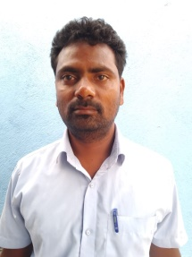
Kalyani.S.Sagar
: kalyanisagar672@gmail.com
at:sangolagi(c) post:chinchansoor
Aland, Gulbarga-585104
: +91 9880689280

OBJECTIVE

To learn advanced technical skills and to grow professionally such that my growth adds up to the assets of the organization.
ACADEMIC DETAILS

Qualification | Institution | University  /Board | Year of Passing | Aggregate (%)
B.Ped | B Shyamsunder College Gulbarga | Gulbarga University Gulbarga | 2013 | 64.17
B.A | Dr.Ambedkar degree college arts & commerce | Gulbarga University Gulbarga | 2012 | 60.17
12th | Govt. independent pu college | DPUE-Kar | 2009 | 41.5
10th | The Govt. High School-chinchansur | KSEEB | 2006 | 38.56

TECHNICAL SKILLS
Basics & MS Office.
KEY STRENGTHS

- Values interpersonal relationships.
- Initiate, form teams and organize well.
- Good communication skills
- Positive attitude.
- Good decision making skills
- Disciplined, motivated

PERSONAL INFORMATION
Date of Birth : 4th june1990
Gender : Male
Languages known : English, Hindi, Kannada,
Permanent Address : At:sangolagi(c), Post:chinchansur, Tq:Aland, Dist:Gulbarga-585104
Marital Status : Married
Nationality : Indian
HOBBIES
- Listening to music,
- reading books,
- learning new things

Date:

Place: Gulbarga. (Kalyani. S. Sagar)

